**NPS Survey**

This document summarizes the setup of sending Surveys to customers through Email. The customers will receive an email once in 90 days. The user could give a rating of 1-10 and also could give a comment and these details will be stored on NPS Record. If the user edits the response through the same link, the corresponding record will be updated with new changes.

We’ve used a Map/Reduce script, Suitelet script, and an Email template for the process. The script will consider 7 customers per execution ( For the client’s requirement. Initially it was 200). There are 2 custom fields available on the Customer record; **Last survey Send date** and **Exclude From NPS Survey.** The last survey send date filed will hold the date where the customer got the last NPS Survey, whereas if the Exclude from NPS Survey Checkbox is checked, that particular customer won’t get any NPS Survey.

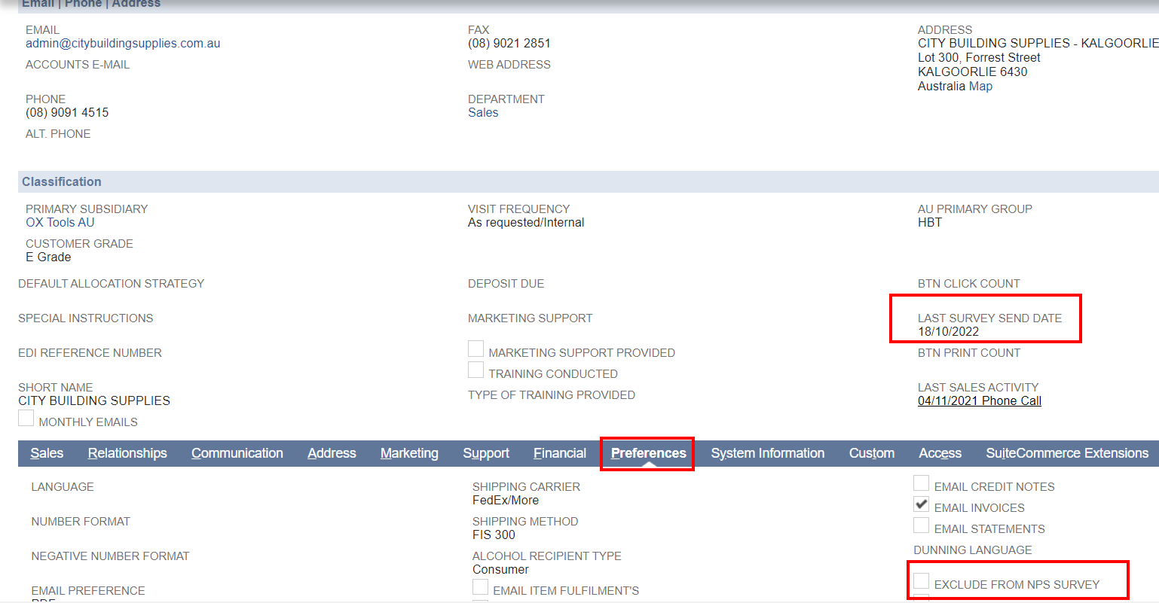

If a set of customers got the mail after 90 days, they have the chance to get the next survey. But if still there are customers who have gotten any survey emails, then such customers will be considered first. For e.g.: if there are a total of 1000 customers, the first 7 will get the mail on the first day. From the 91st day, these customers are eligible for getting Survey mail. But there are 5 more customers are there who never get any survey emails, then the script will consider these 5 customers first, and 2 from the first set of customers who got a survey on the first day will be added. The remaining 5(7-2) customers will get the mail on the next execution.

**NPS Survey Response Record**

When the Map/Reduce script is executed, an email will send to customers (7 customers per execution) who satisfies following conditions;

* Is not inactive
* Should have Email address on Primary Contact
* The **Exclude from NPS Survey** checkbox should be unchecked
* The subsidiary should be **OX Tools AU**
* Last survey send date should be either Empty or Should be before 90 days

The mail will be as follows;

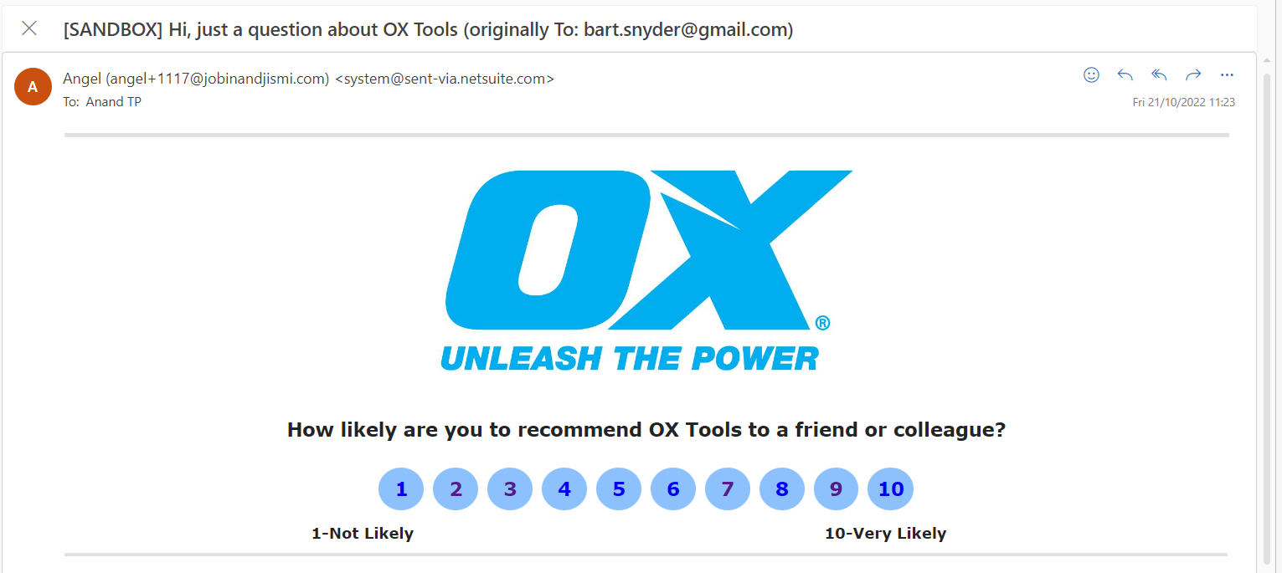

The customer could give a rating from 1-10. After giving the rating, another page will open, where they could add any additional comments

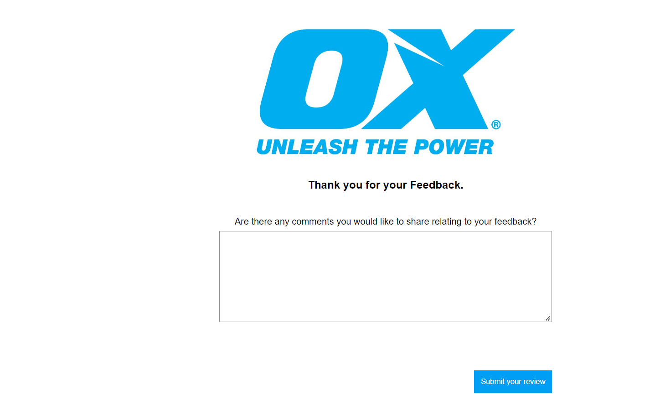

On the button click a Thanks message will pop up on the next page. If any other error occurs an error message will be showed on the page

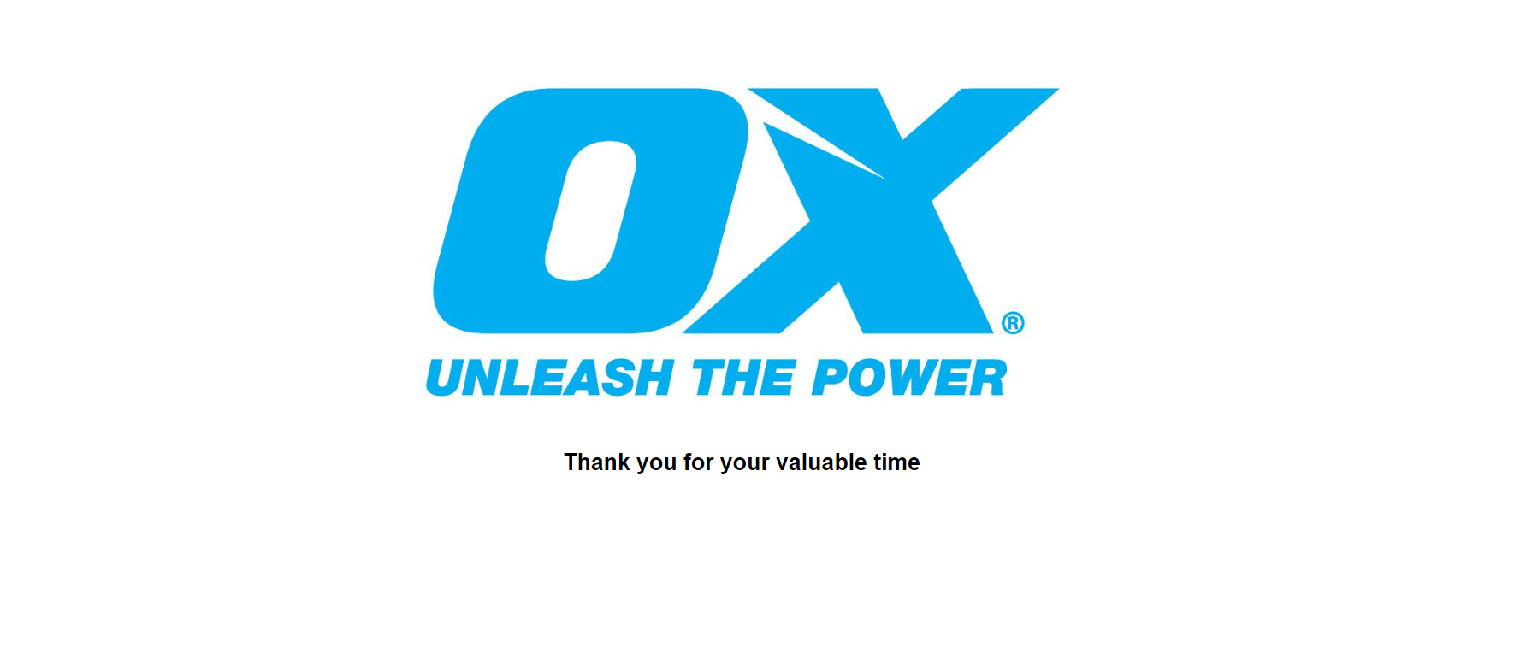

All of these details will be stored on a custom record [NPS Survey Response](https://3425005.app.netsuite.com/app/common/custom/custrecordentrylist.nl?rectype=2320) . The record is locked by a workflow [JJ NPS Response Record Locking.](https://3425005.app.netsuite.com/app/common/workflow/setup/nextgen/workflowdesktop.nl?id=311&e=T&whence=#) The custom record has 3 status; **Not Initiated**, **Mailed** and **Responded**. Not initiated is the primary state and when the mail is send to the customer, it will become Mailed and when the customer give response/rating, it will become Responded.

**Related Scripts**

[JJ MR Email Survey OTGA-1515](https://3425005.app.netsuite.com/app/common/scripting/script.nl?id=3419)

This Map/reduce script is used for listing the customers for sending survey. This script also creates the custom record NPS Survey Response that stores the responses from Customers and sends NPS Survey through Email to each customers . This script is scheduled on daily basis. Ie; it will execute every day and sends survey to maximum of 7customers each day. customers will receive an email once in 90 days

[NPS Survey](https://3425005.app.netsuite.com/app/crm/common/merge/emailtemplate.nl?id=799&e=T)

This is the Email Template used for the NPS Survey that send to customers through Email . This includes a rating of 1-10 where each has the link to the suitelet that has next page.

[JJ SL NPS Survey OTGA-1515](https://3425005.app.netsuite.com/app/common/scripting/script.nl?id=3420)

This suitelet contains the Additional Comment section that the customers could add after giving the rating. It loads another [HTML file](https://3425005.app.netsuite.com/app/common/media/mediaitem.nl?id=41048169&e=T) to view the section. The user could either give/ skip this section. When the user submits this page, it will lead to another page that contains a confirmation/ Thanks message that the customer gave through the NPS survey. It is also using another [HTML file](https://3425005.app.netsuite.com/app/common/media/mediaitem.nl?id=41048171&e=T) to show the Thanks/Confirmation message. It is also using another [HTML file](https://3425005.app.netsuite.com/app/common/media/mediaitem.nl?id=41047132&e=T) to show the Error message if there is any error occurred

**Working Steps**

* Customizations > Scripting > Scripts

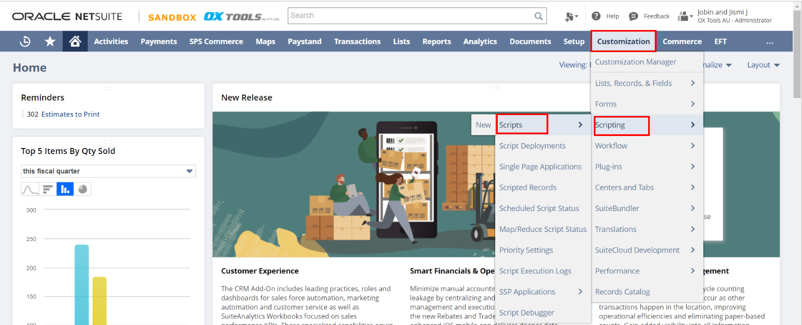

* On the list select [JJ MR Email Survey OTGA-1515](https://3425005.app.netsuite.com/app/common/scripting/script.nl?id=3419)

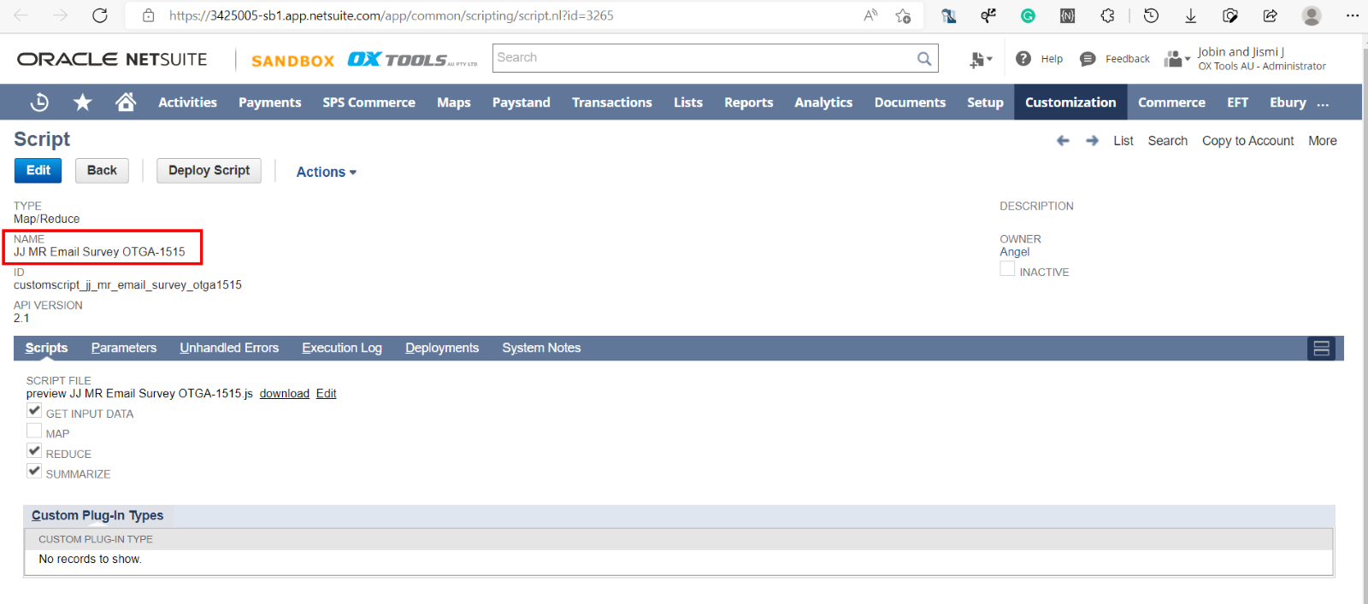

* On the **Deployments** tab select the Deployment record of the script

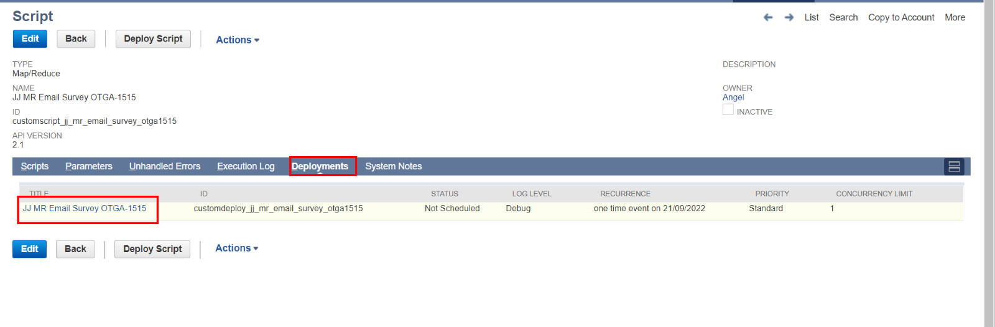

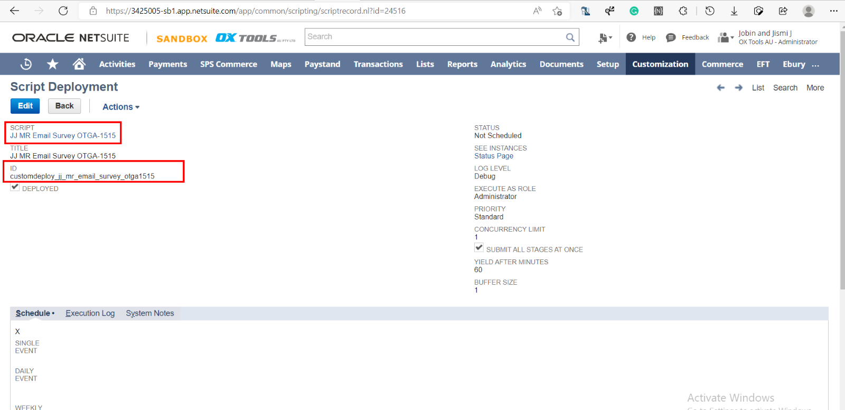

* Edit the record and click **Save & Execute**

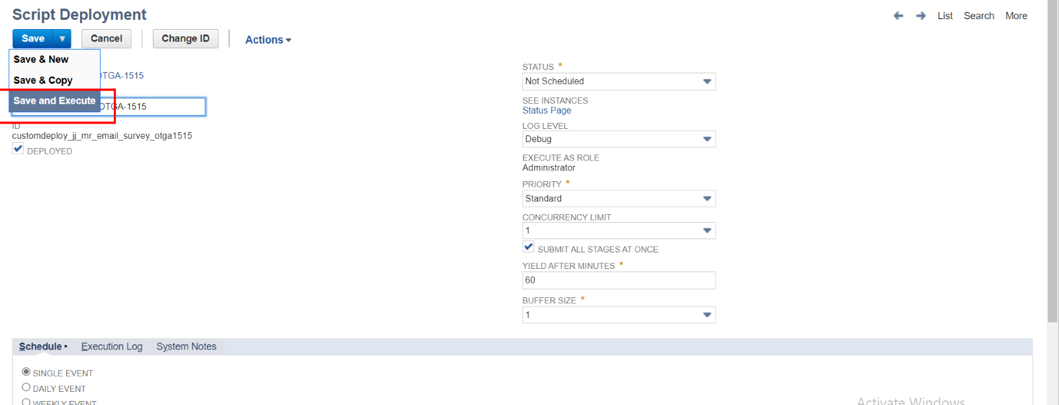

* On the next page, click Refresh button, until the status becomes **Completed**

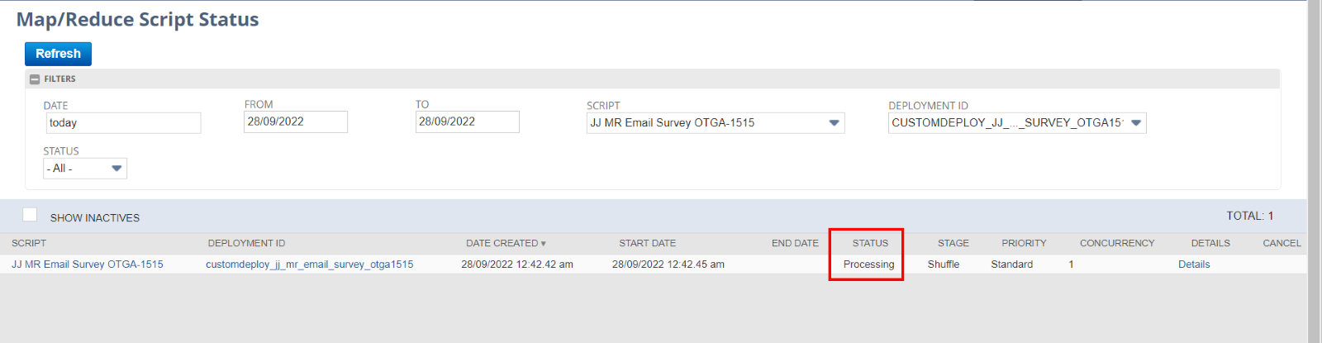

* Emails will be sending on the Background. Open the Email send to the Customer

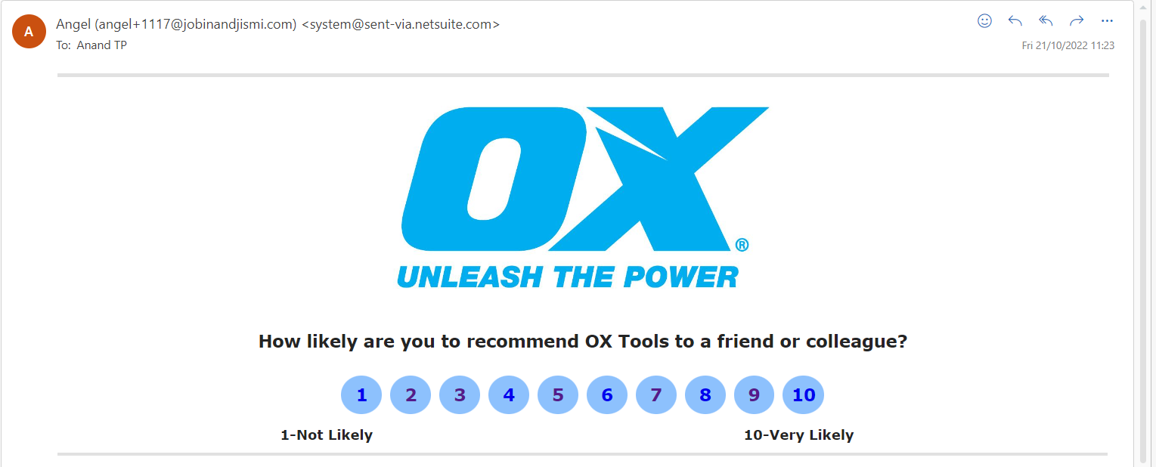

* Click on the Rating which you want to give. It will lead to the Comment page and give comment if you want or you could leave the section and click on the **Comment** button

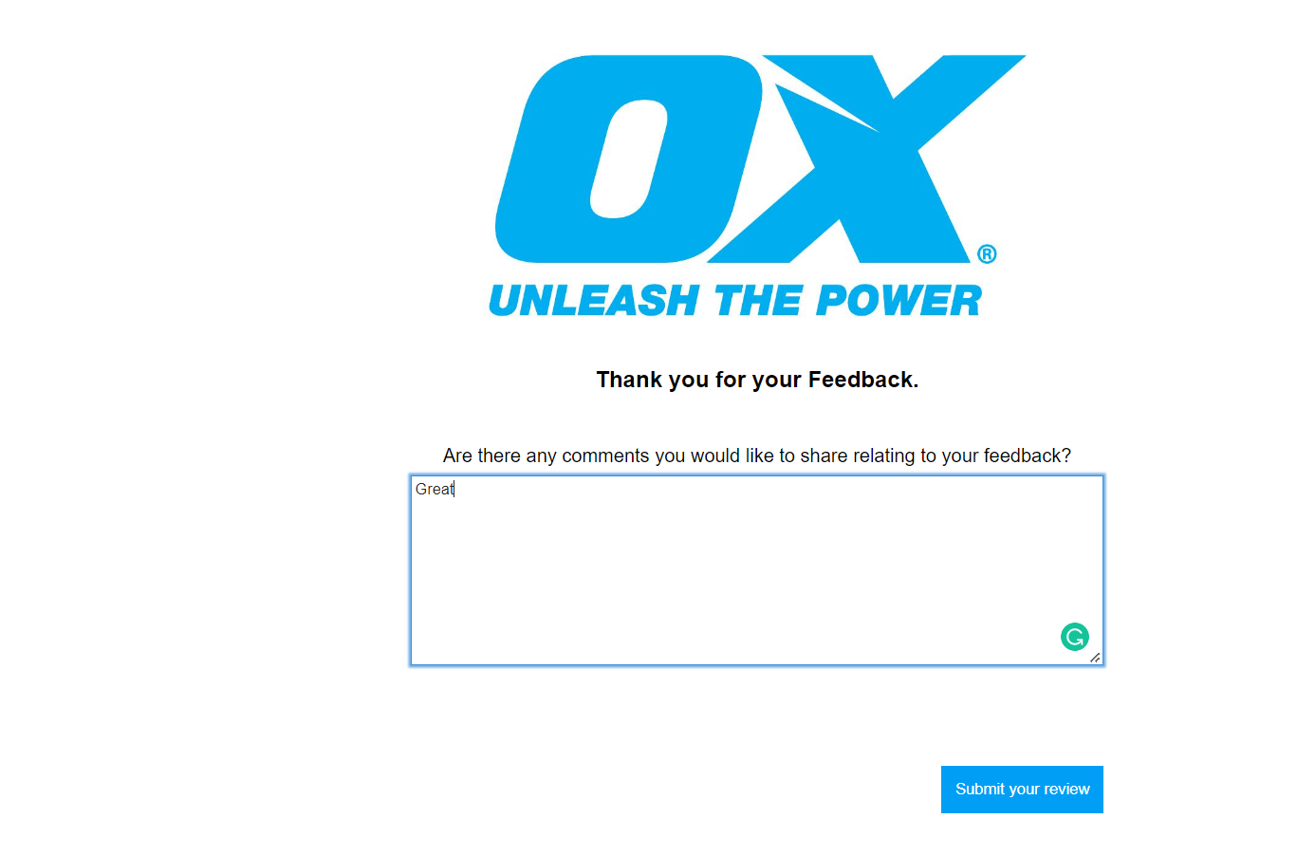

* By clicking the **Submit Your Review** button, the window will lead to the last page that contains Thanks message. The user could close the tab after this.

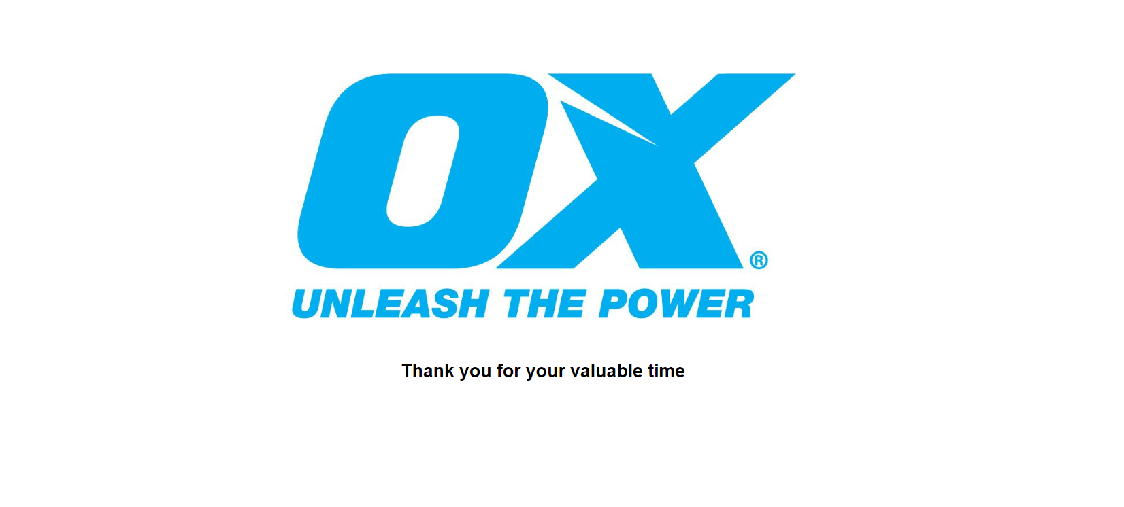

* Open the custom record [NPS Survey Response](https://3425005.app.netsuite.com/app/common/custom/custrecordentrylist.nl?rectype=2320) list and open the record which the response from the Customer has updated

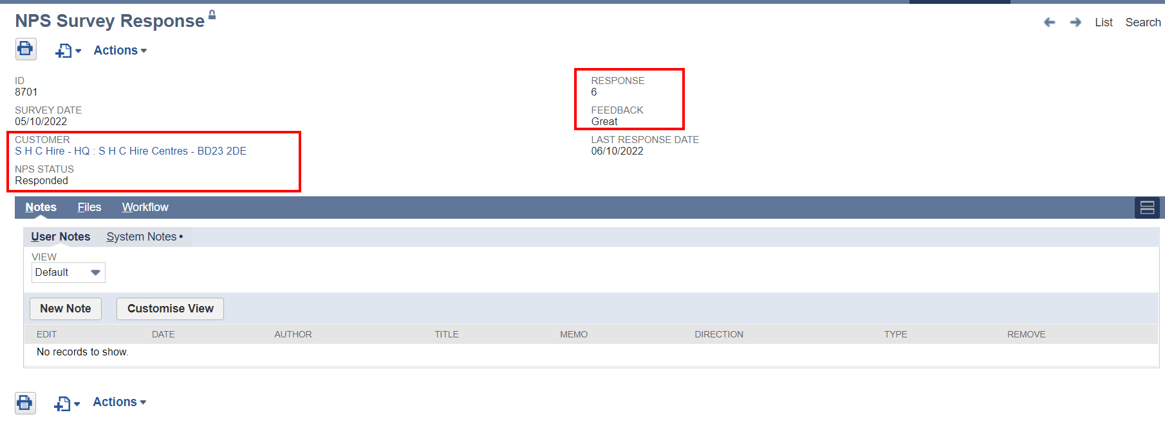

* Response and all the details will be stored on the record. It also has the Date when the survey is send to customer and the Date when the customer made last edit etc.
* Initially the status of the record will be **Not initiated.** After sending the mail to the customer it will be changed to **Mailed** and after the customer gives the rating/ feedback, the status will be **Responded**

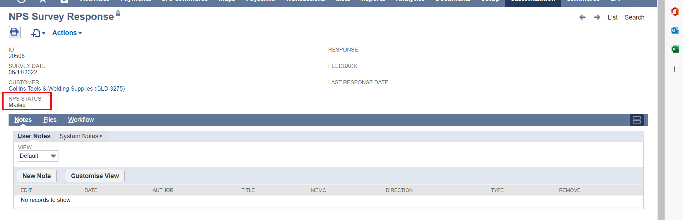

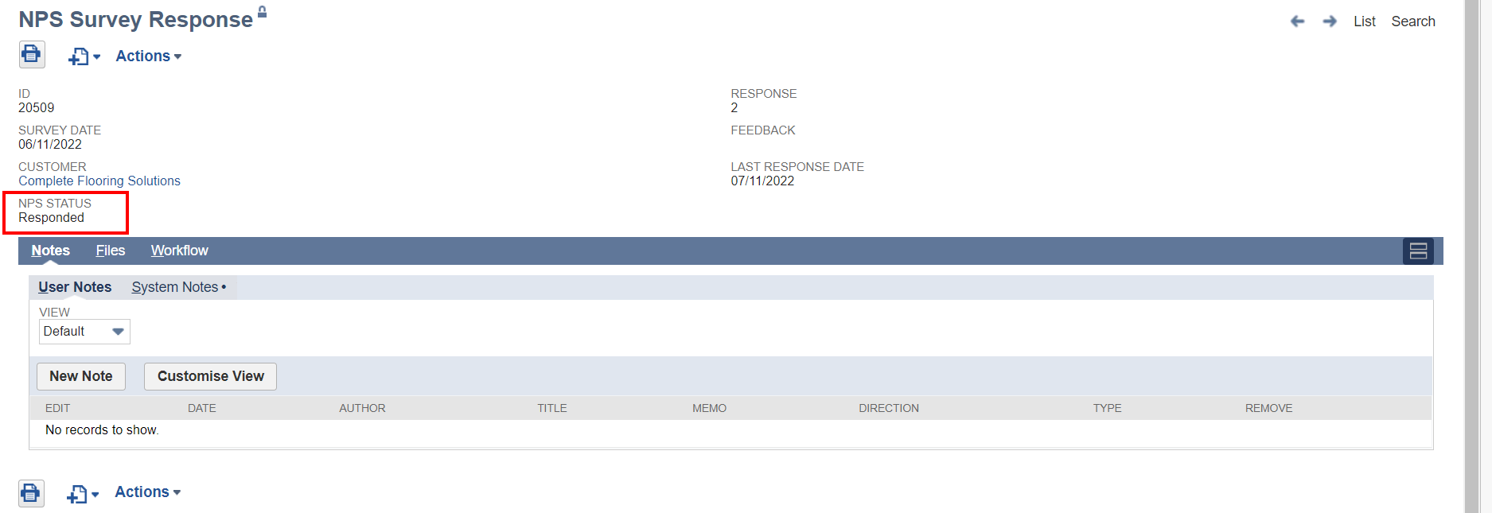

* Go to the customer record and check the **Last survey Send date**  value on the record. This will be the Date which the customer got the last survey email

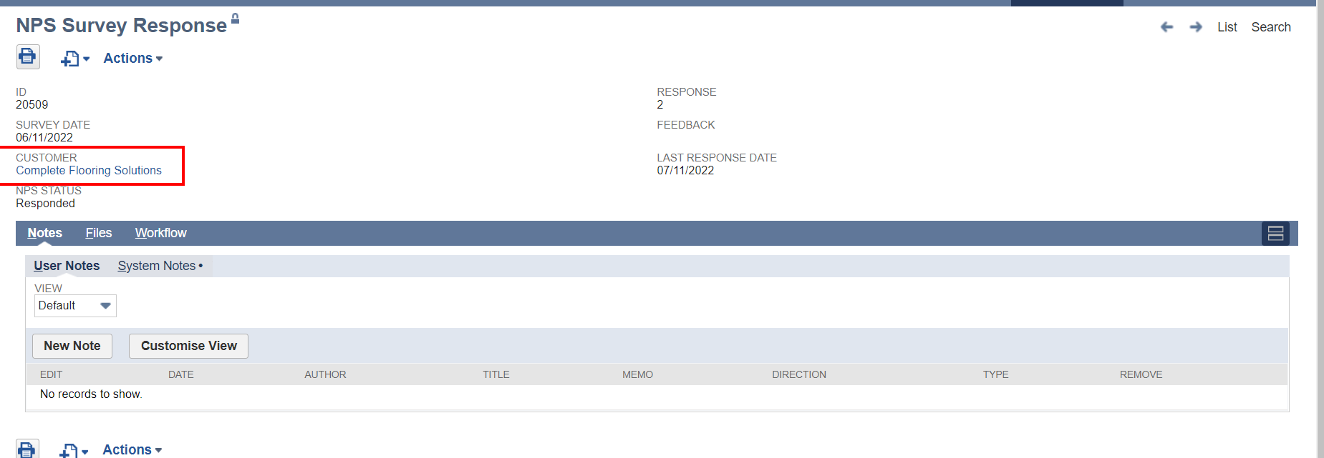

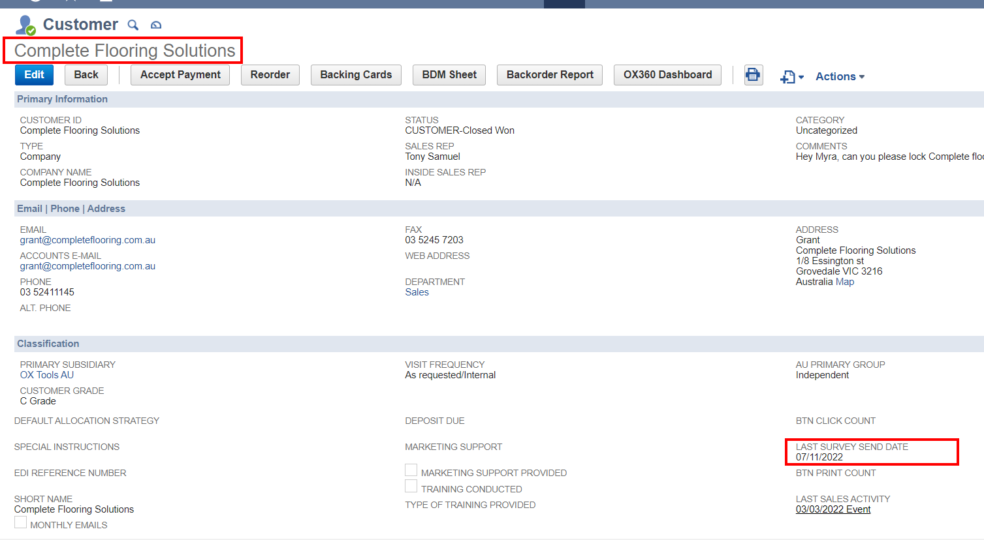

* To view all the customers responses on the dashboard, got to Home page there you can see the portlet

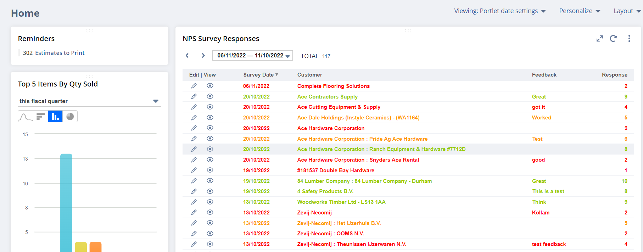

* If some error Occurs

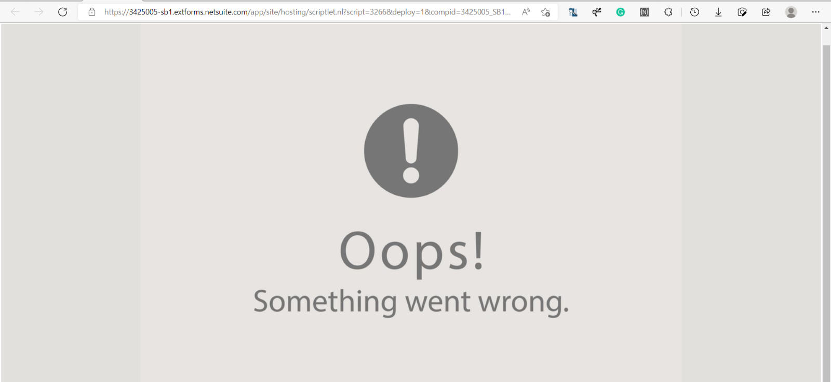

**Notes:**

* Currently, the MR script has a scrip parameter to select the author of the mail. If the user need to change the author of the mail, they could change it from the script [deployment](https://3425005.app.netsuite.com/app/common/scripting/scriptrecord.nl?id=26557) record of the script

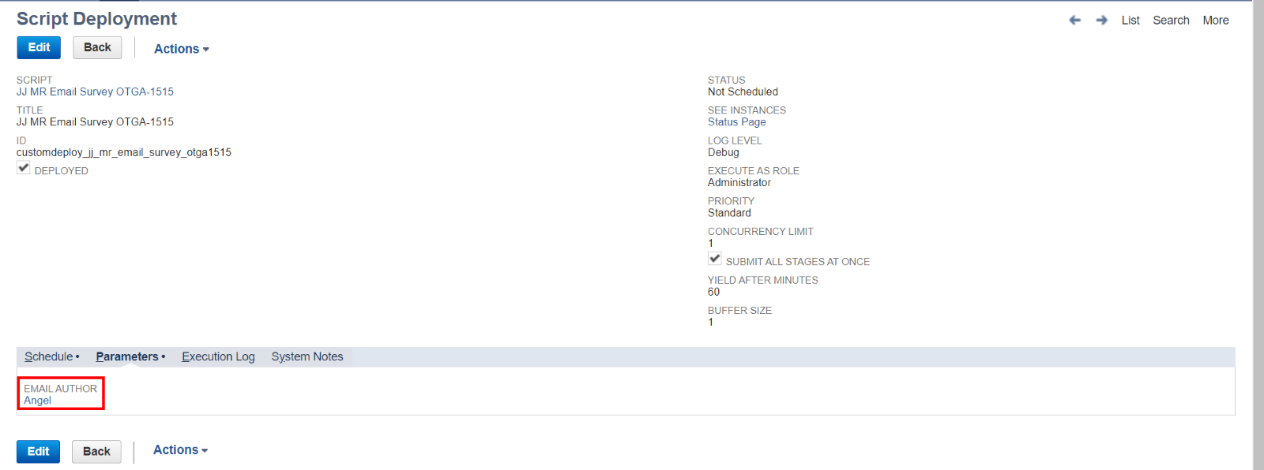

User can only select the employee who has email address.

* Previously if the user deletes the custom record before responding, a blank page will occur when the user tries to respond to the deleted record. To overcome this scenario, I’ve added a new [workflow](https://3425005.app.netsuite.com/app/common/workflow/setup/nextgen/workflowdesktop.nl?id=311&e=T&whence=#)  that locks the custom record. So, nobody can’t edit/ delete the custom record through the UI. So, it won’t affect the working of the survey.